Hedgehog Class Home Learning Monday 30th March 2020

English/Phonics

CGP Book – next 2 pages please

Phonics – Mr Mc – Day 3 and the digraph is ‘ur’

<https://www.youtube.com/watch?v=N_eMHC35n24>

Possible follow up ideas –

Sorting ur words into real and alien words (will attach a copy to the bottom of this plan)

The Enormous Turnip

<https://www.youtube.com/watch?v=mGw5yTOPTSQ> retold by Irene Yates

Vocabulary – can your child think of any other words to describe how big the turnip is? (In the story they say huge, vast, enormous)

Can your child join in the repeated refrain (the part of the story that repeats ie but the enormous turnip just wouldn’t budge!)

Can your child label the characters from the story using their phonic skills? They may like to extend their writing by writing about their favourite part of the story i.e. I like when they all fell over at the end.

Topic – Change

Linked to the story can your child explore the forces of push and pull. Are there objects that you can change the force from push to pull for example a microwave door – you pull to open it then change to a push to shut it.

Cut and stick sorting activity linked to Push and Pull.

Maths

Any warm up activities ie watch and join in with Big Numbers Song

A new song to listen to is Everybody Get Up by Mr Mc. He counts in 1s to 20, in 5s to 50 and in 10s to 100. <https://www.youtube.com/watch?v=aKvgwVAGSgw>

Next 3 pages in CGP Book please

Language of size – linked to vocabulary from the story of The Enormous Turnip

Could your child find toys/objects around the house and garden that they can order by size. Did they start with the largest or smallest? Please take a photo if you can so I can see how many objects they were able to order!

Collective Worship - <https://www.youtube.com/watch?v=F7r2jaciG0g>

The Triumphal Entry – Palm Sunday

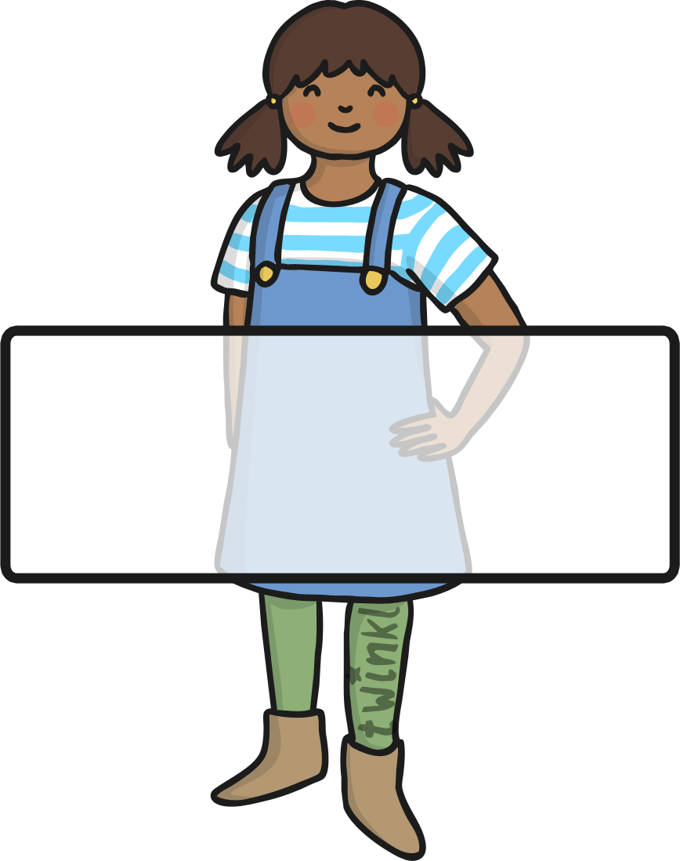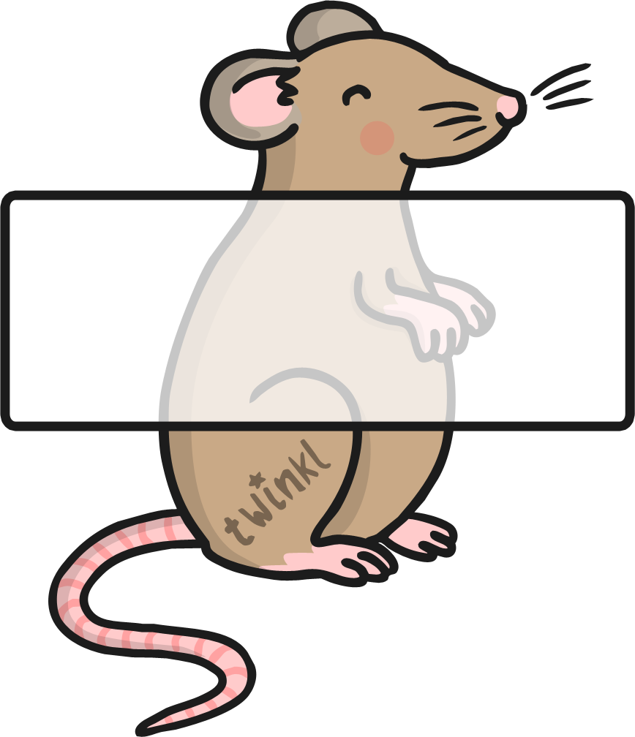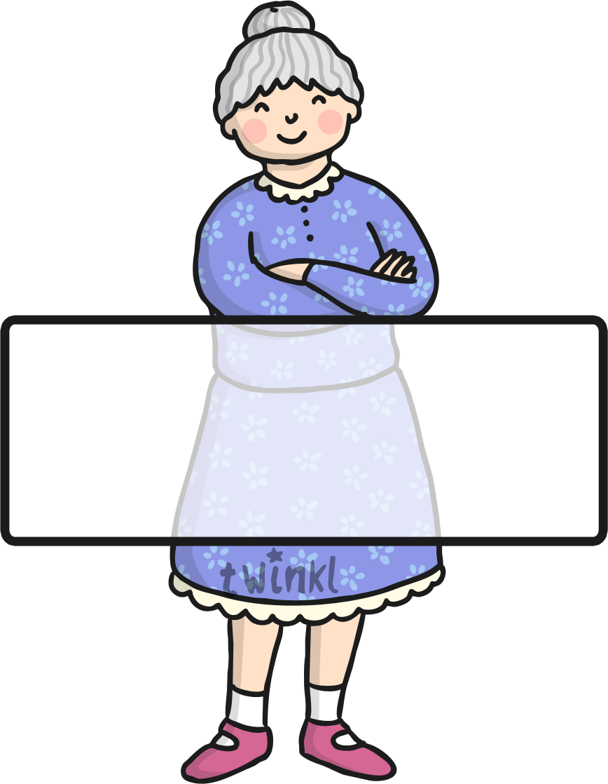Characters from The Enormous Turnip

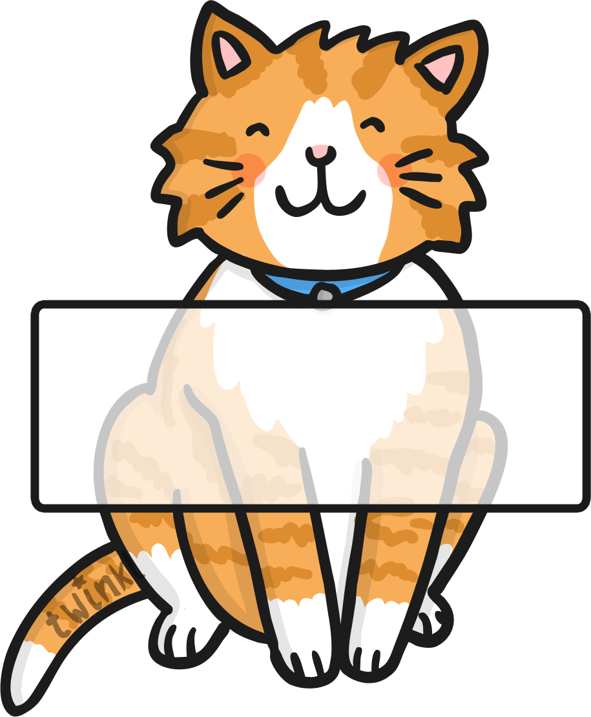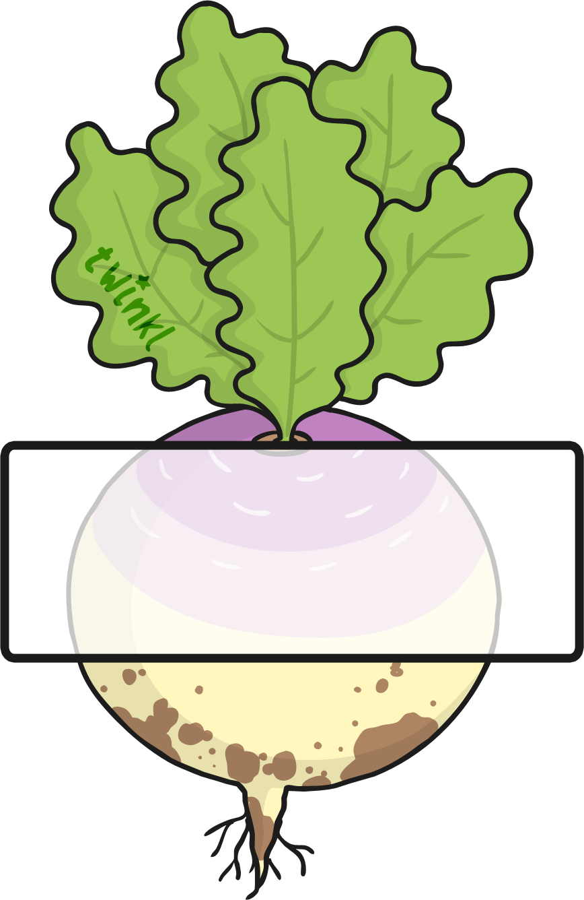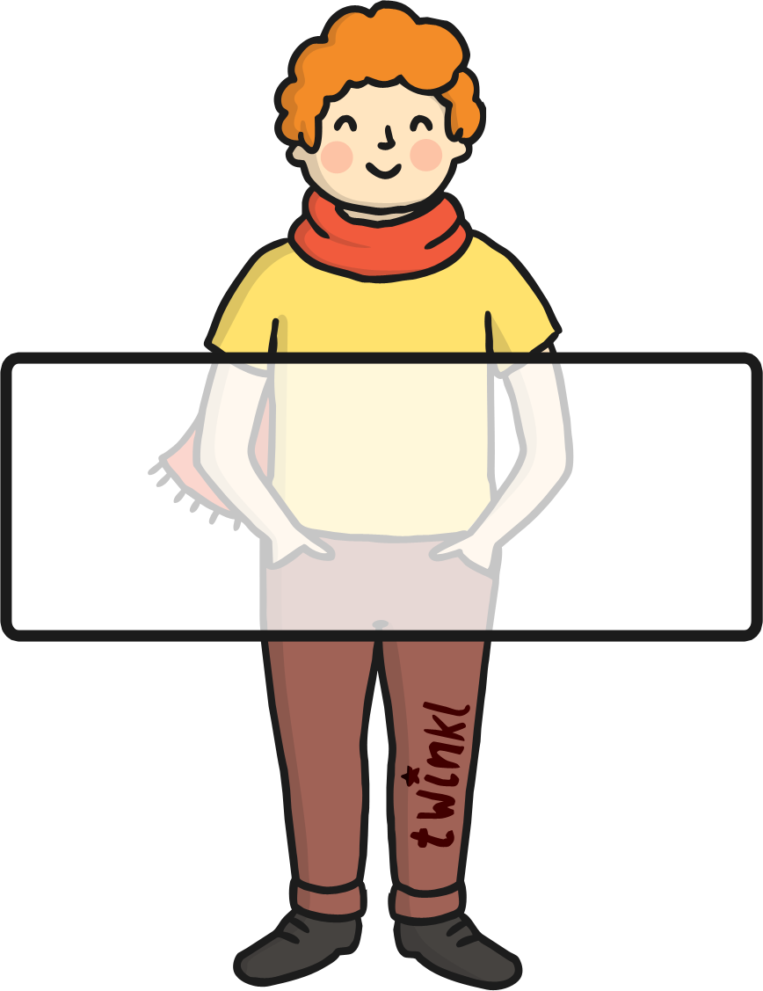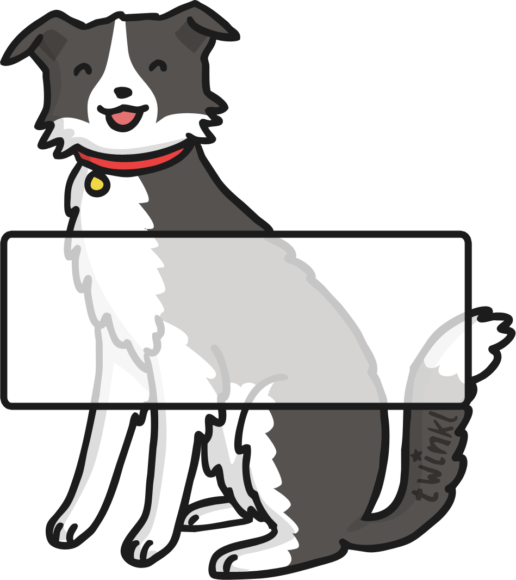

**TEXT HERE**

MBP SSD:Users:Sue:Desktop:Phase-3-ur-Colour-by-Phoneme-Real-and-Nonsense-Words-Activity-Sheet.pdf

