Learning Objective
We can use the apostrophe to indicate possession with both singular and plural nouns.

Challenge 1
Highlight the word with the correct apostrophe use.

- The rainforests’/rainforest’s tropical environment is perfect for sloths.
- Sloths’/sloth’s coats are covered in algae.
- In daylight, a sloth’s/sloths’ poor eyesight makes it almost blind.
- In the dark, the various predators’/predator’s glowing eyes searched for sloths.
- The sloth’s/sloths’ diets consisted mainly of buds, leaves and tender shoots.
- Clambering back up the tree, the sloth’s/sloths’ movement was very slow.
- A sloth’s coat can become an insects’/insect’s home.

Challenge 2
Finish these sentences in your own words, paying attention to the position of the apostrophe.

- Sloths’ coats ____________________________________________________.

- The presenter’s adoration for sloths ___________________________________.

- A jaguar’s dinner ___________________________________________________.

- The sloth’s slow movement ___________________________________________.

- The rainforest’s trees ______________________________________________.

Challenge 3
Using some of the words on the Word Wall, write a short paragraph describing an average day for a three-toed sloth. Can you include 3 apostrophes for possession in your writing? Try to include sentences that show possession with both singular (one) and plural (more than one) nouns.
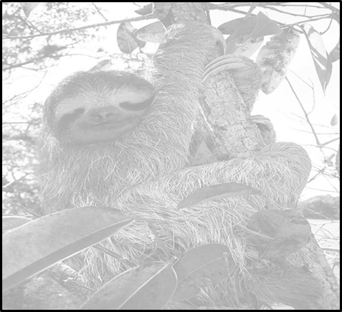
Word Wall
lethargic
sloth’s
presenter’s
camouflaged
predators’
sluggish
munched
three-toed
clung
jaguar’s
grubby fur
algae-covered

