Let's talk PANTS! (The Underwear Rule) | NSPCC
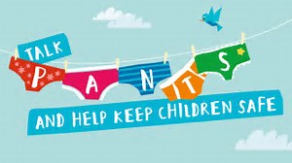
The NSPCC Underwear Rule is taught in schools to deliver messages to pupils that help keep them safe from harm and abuse.
The resource is aimed primarily at pupils aged 5-9 and uses the acrostic message PANTS. The resource aims to deliver the key messages that:
- Privates are private
- Always remember your body belongs to you
- No means no
- Talk about secrets that upset you
- Speak up, someone can help
https://www.nspcc.org.uk/preventing-abuse/keeping-children-safe/underwear-rule/

