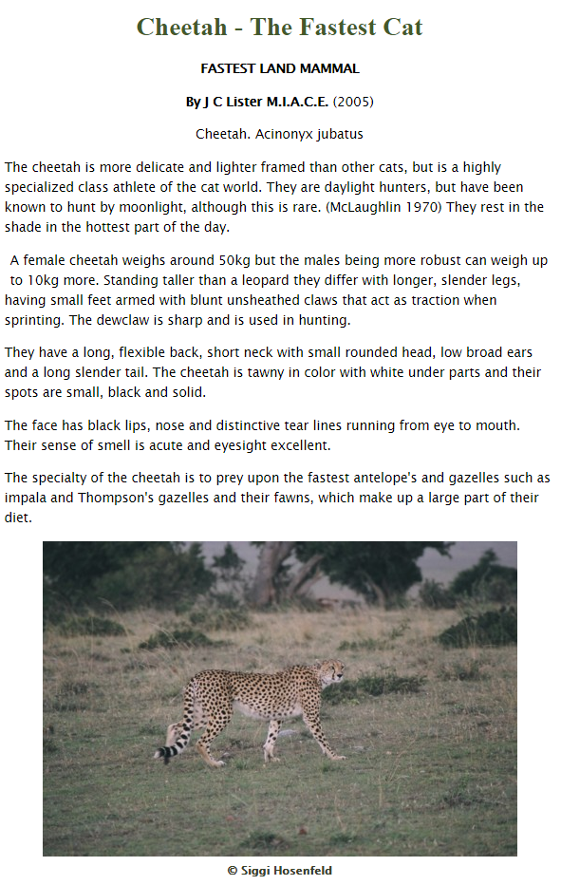
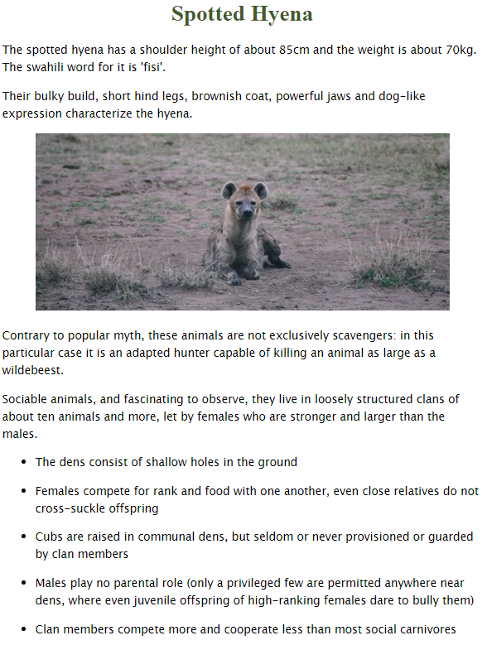

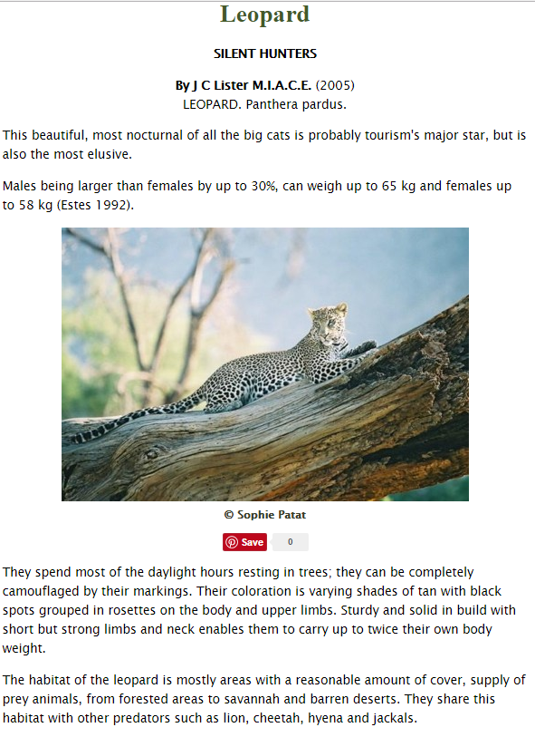

African Animals Reading Comprehension
- Which animal or animals are nocturnal?

- Which animal has been known to hunt by moonlight?

- Which is taller? A leopard or a cheetah?

- Write down 3 animals that a cheetah would eat:

- Which part of a hyena is ‘dog-like’?

- The leopard is described as ‘elusive’. What do you think this means? Can you find out using a dictionary?

- Leopards can carry up to twice their body weight.
True or False?

