Questions to ask your child when reading 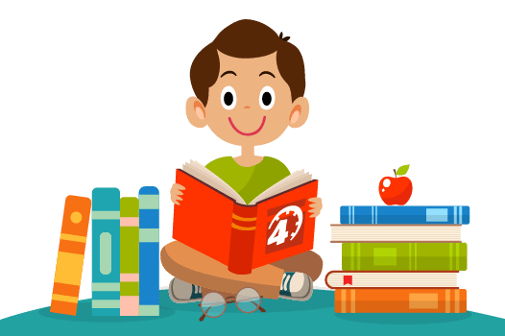
Key Stage 1
Before reading the book:
Can you point to the title? or What is this? (pointing to the title)
What do you think this story will be about? What might happen in the story?
What do we call the writing on the back of the book? (Blurb) or What does the blurb tell us?

During the reading of the book:
What is happening in the pictures?
What has happened so far? Is it what you expected to happen?
What might happen next? How do you think the story might end?
What sort of character is….? Is he/she friendly/ mean/ nice…?

At the end of the book:
Did you like this book? Why? (Encourage children to develop their opinion about books by encouraging them to explain their reasons)
What was your favourite part? Why?
What was the most interesting/ exciting part of the book? Can you find it?
What sort of character was….?
Why did that character do … (give a situation/ event from the story)?
What happened in the story?

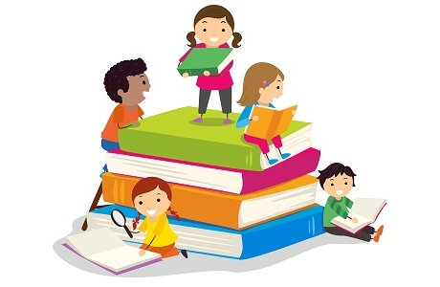
Key Stage 2
Before reading the book:
What do you think this story will be about?
What might happen in the story?
What genre will this story be? E.g. fantasy, comedy, horror.
What do we call the writing on the back of the book? (Blurb) or What does the blurb tell us?

During the reading of the book:
What has happened so far? Is it what you expected to happen?
What might happen next?
How do you think the story might end?
Who is your favourite character? Why?
Who is the character you like least? Why?
Find 2 sentences, which describe the setting.
Is the plot fast or slow moving? Find some evidence in the text, which supports your view.

At the end of the book:
Which part of the story is your favourite / least favourite? Why?
Would you change any part of the story? How?
Would you change any of the characters? How?
Which part of the story was the funniest, scariest, saddest, and happiest? Find some evidence in the text to support your opinion.
Would you like to read another book by this author? Why?
Does your opinion of this character change during the story? How? Why?
If you met one of the characters from the story, what would you say to him / her?
Find 2 things the author wrote about this character that made him / her likeable or unlikeable?

