Nar Valley Federation

5-week Animal Project

For the next 5 weeks we are going to be working on an animal project. Mrs Neary thought that this would be a lovely way for the whole of the Federation to complete the last few weeks of this academic year.
Each week there will be a different element that looks at different habitats or types of animals. These will build up week on week to create your overall project, which we would like you to bring into school when we return, so that we can share and celebrate the learning that you have been doing.
- Week 1 – Nocturnal Animals
- Week 2 – Peru – South American Animals and Habitats
- Week 3 – Sea Creatures
- Week 4 – African Animals – The Savannah
- Week 5 – Endangered Animals

We will be covering all different areas of the curriculum during the weeks and providing links, videos and other useful resources and ideas.

Nar Valley Federation – Animal Project
Nocturnal Animals

Vocabulary:
burrow owl rodent prey predator habitat behaviour nocturnal night dusk twilight forage hunt/hunter creature species senses nest physical traits adaptation manoeuvrability
https://www.bbc.co.uk/bitesize/clips/zsshfg8 Video on Nocturnal animals - primary  https://www.youtube.com/watch?v=SFG7etbxl5o Nocturnal Song EYFS KS1  https://www.youtube.com/watch?v=TPQRiSTYFHo Owl Babies Story – Martin Waddell  https://www.bbc.co.uk/programmes/b01llxgf - short video clips about nocturnal animals around the world KS2  https://www.youtube.com/watch?v=mNnbvPdVYRU How to build a hedgehog home video  https://www.nationalgeographic.com/animals/reference/nocturnal-animals-explained/ KS2 Information  https://www.topmarks.co.uk/Search.aspx?q=nocturnal+animals KS1/ KS2 | Book Ideas:  Fiction  Appleblossom the Possum 8-12yrs  A boy called Bat 6-10yrs  Stellaluna 4-7yrs  The Moonkeeper 4-8yrs  Bats at the Beach 5-8yrs  Owl Babies 0-5yrs  The Night Flower 3-7yrs
EYFS / Y1

YR - Watch and learn about nocturnal animals:
https://www.bbc.co.uk/bitesize/clips/zsshfg8 Video on Nocturnal animals - primary

Activity:
YR – Create an oral riddle on a nocturnal animal such as an owl, badger or bat.
Example:

Owl
Hoot, hoot is the noise I make
Night sky is when I wake
Silently swooping, mice be aware
Barns, trees and sheds are where I live

Activity:

Draw a picture of a nocturnal animal and write some labels

Listen to a story:
https://www.youtube.com/watch?v=TPQRiSTYFHo Owl Babies Story – Martin Waddell

Listen / Learn a song:
https://www.youtube.com/watch?v=SFG7etbxl5o Nocturnal Song EYFS KS1

If you are up as we go into the evening, go outside, sit quietly and listen, what do you hear? What do you see?

Curl up and enjoy as many books and stories about nocturnal animals – there are so many out there

Year 1

Y1 - Watch and learn about nocturnal animals:
https://www.bbc.co.uk/bitesize/clips/zsshfg8 Video on Nocturnal animals – primary

Activity:

Draw a picture or choose an image to print off, of your nocturnal animal and write some sentences about it.

Remember:
- capital letters
- full stops
- conjunctions (and & because)
- adjectives (describing words)
- finger spaces.

Word bank below

Listen to a story:
https://www.youtube.com/watch?v=TPQRiSTYFHo Owl Babies Story – Martin Waddell
Listen / Learn a song:
https://www.youtube.com/watch?v=SFG7etbxl5o Nocturnal Song EYFS KS1

If you are up as we go into the evening, go outside, sit quietly and listen, what do you hear? What do you see?

Curl up and enjoy as many books and stories about nocturnal animals – there are so many out there

Year 2 /3

Research:

https://www.bbc.co.uk/bitesize/clips/zsshfg8 Video on Nocturnal animals - primary
https://www.nationalgeographic.com/animals/reference/nocturnal-animals-explained/ KS2 Information
https://www.topmarks.co.uk/Search.aspx?q=nocturnal+animals KS1/ KS2
https://www.bbc.co.uk/programmes/b01llxgf - short video clips about nocturnal animals around the world KS2

Activity:

Create a fact file on a nocturnal animal.

Look below for
Y2/3 planning template and example to remind you of the features needed – be as creative as you can. This could be in the shape of your animal of choice, it could in the shape of a full moon, surprise us.

If you are up as we go into the evening, go outside, sit quietly and listen, what do you hear? What do you see?

Curl up and enjoy as many books and stories about nocturnal animals – there are so many out there

Years 4/5/6

Research:
https://www.bbc.co.uk/bitesize/clips/zsshfg8 Video on Nocturnal animals - primary
https://www.nationalgeographic.com/animals/reference/nocturnal-animals-explained/ KS2 Information
https://www.topmarks.co.uk/Search.aspx?q=nocturnal+animals KS1/ KS2
https://www.bbc.co.uk/programmes/b01llxgf - short video clips about nocturnal animals around the world KS2

Activity:

Create a leaflet about a nocturnal animal (examples below)

This should be research well, you can present you work in any way that you would like – it can be computer generated, folded in quarters, concertina style or be creative, if the shape of your animal of choice badger, owl, surprise us.

If you are up as we go into the late evening, go outside, sit quietly and listen, what do you hear? What do you see? What do you smell?

Curl up and enjoy as many books and stories about nocturnal animals – there are so many out there

Science:  Build a habitat. Any habitat you like, a bug hotel, a hedgehog, owl or rodent for instance  See attachments for advice and instructions on a hedgehog home, but there are many others you could research. Go and have a look around your garden, can you see a natural habitat. Turn over a log, what’s underneath?  Take a photo for your project – send the photo in we could then make a gallery on the website  https://www.youtube.com/watch?v=mNnbvPdVYRU – How to build a hedgehog home video | Art  Create a picture / sculpture of your chosen animal. Use a medium of your choice  - Paint  - Crayon  - Sketch  - Pastels  - Collage  - Textiles  - Junk modelling  - Recycling materials

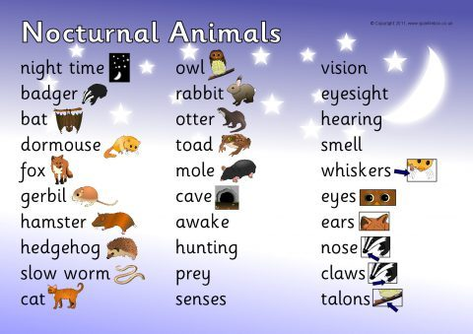
YR – Y2 Word Mat

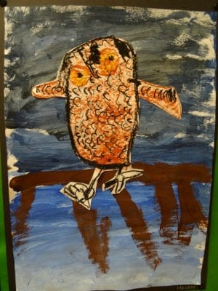
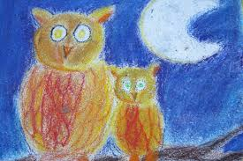
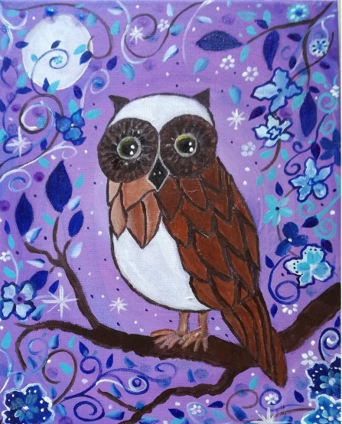
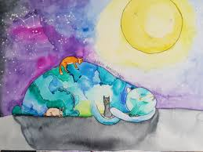

Title | Green Turtle
Classification | Green Turtles are reptiles.
Appearance | The Green Turtle has 4 flippers. It has a hard shell and scales. They are a greenish colour.
Diet | Green Turtle eat seagrass, algae, jellyfish and the fruits of mangrove trees.
Movement | Green Turtles use their strong flippers to glide through the water. On land they are heavy and slow.
Habitat | Green Turtles live mainly in tropical seas, where the water is warm.
Reproduction | The female Green Turtle lays between 60 and 150 eggs on the beach. She buries them in the sand to protect them.
Interesting Facts | The male Green Turtle never comes onto the land.
Title
Classification
Appearance
Diet
Movement
Habitat
Reproduction
Interesting Facts

Examples for Y2/3
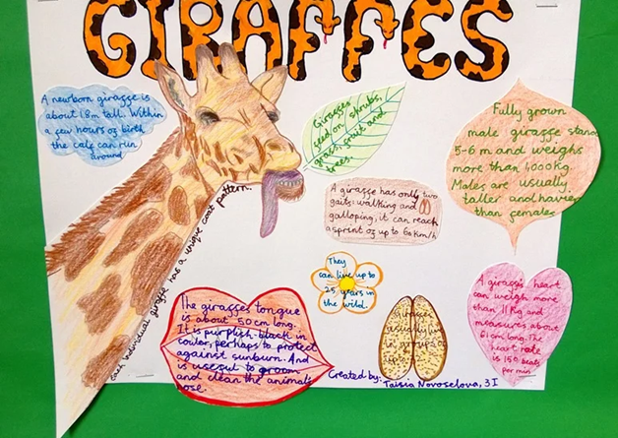
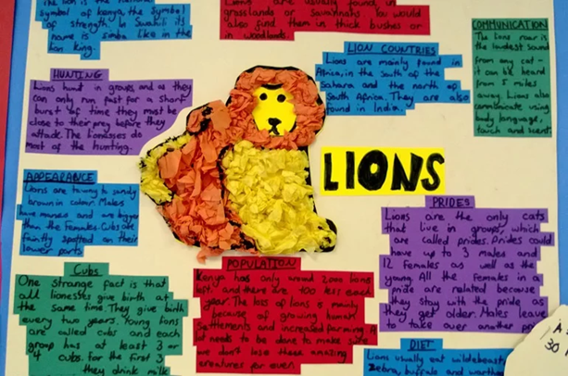
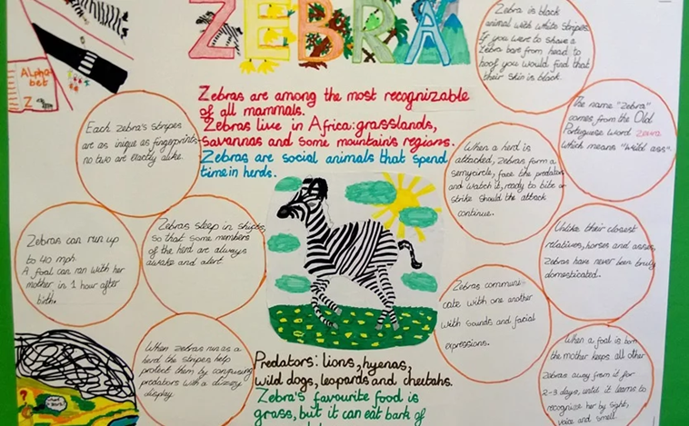
Examples for Y2/3

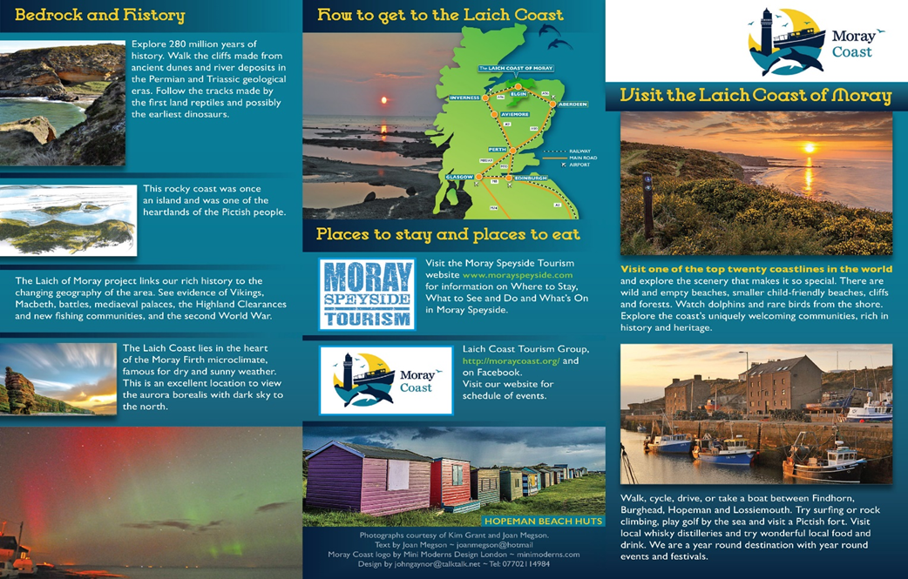
Examples for Y4/5/6

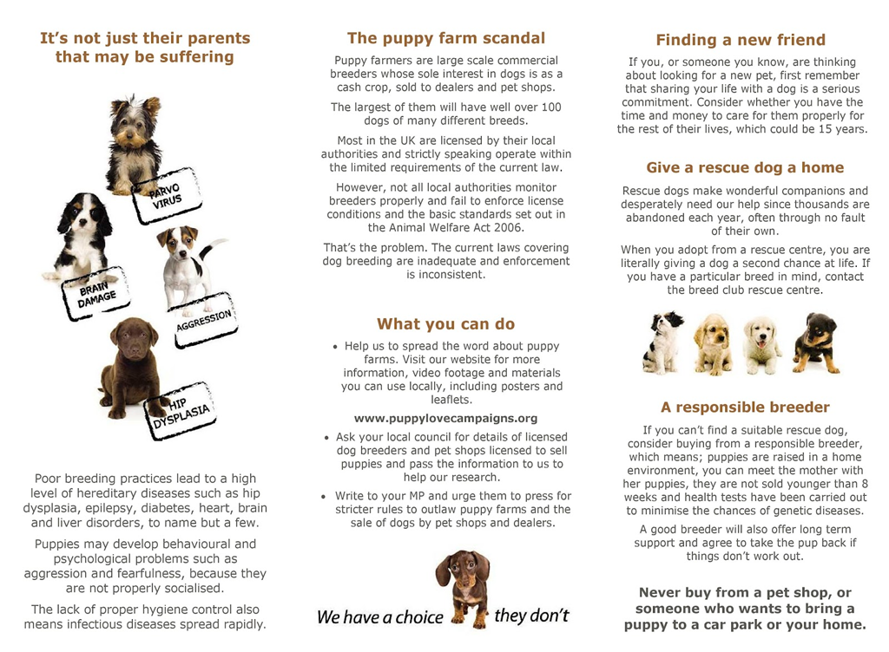
Examples for y4/5/6

